**APPLICATION FORM TO COMPLETE TECHNICAL INFORMATION FOR PATENT FILING**

1. Title of Invention**: SMART MEDICINE DRAWER.**

2. Particulars of Inventor (s) in CAPITALS:

|  |  |  |  |
| --- | --- | --- | --- |
| **S.NO** | **Name** | **Department** | **Designation** |
| 1. | DEEKSHANT TAYA | B.E-CSE | STUDENT |
| 2. | LOVENEET SINGH SLATHIA | B.E-CSE | STUDENT |
| 3. | VANDANA CHAUHAN | B.E-CSE | STUDENT |
| 4. | VIKAS SHARMA | B.E-CSE | STUDENT |

3. Corresponding Inventor’s Name and Address:

|  |  |  |  |  |  |
| --- | --- | --- | --- | --- | --- |
| **Inventor(s) Postal Address Inventor(s) Alternative Address (resi)** | **Deekshant Taya**,  Near red petrol pump sai city collony dhandera roorkee uttrakhand. 247666 | **Loveneet Singh Slathia,** Ward no. 17 Partap Nagar near police line kathua, Jammu and Kashmir.  184101 | **Vandana Chauhan,** Near shanti Bai shishu Mandir, Noorpur road , Jaitra – Dhampur, distt. bijnor , Uttar Pardesh  246761 | **Vikas Sharma,**  HOUSE.NO 152 Sector -16 Hisar,Haryana  125001 |  |
| **Mobile:** | 8264611074 | 7006932203 | 6397730 631 | 7027602785 |  |
| **E-mail:** | Deekshanttaya092@gmail.com | lovrajput42@gmail.com | vandana062224@gmail.com | 18BCS2263@cuchd.in |  |
| **Telephone:** |  |  |  |  |  |

4. Status of Patent :( if application already filed, Application No. with Date,

Please enclose a copy of Patent Application/ (Provisional/ Complete Specifications) as filed)

**Provisional filing with application no— NA**

5. Have you conducted Patent Search? Yes / No (if yes, attach the patent search report) **NO**

6. Brief abstract of invention (In about 500 words):

As we all know in today's world number of diseased people is increasing day by day. As the world is reaching more towards modernization and achieving success, the number of patients or diseased people is also increasing which is a sign of concern. There are various kinds of diseases needing different types of medicines to cure. Many of the diseases are transmitted from person to person by direct or indirect contact. And the most prevalent disease nowadays is of course COVID-19, which is transmitted from person to person or person to community. The most important factor of this pandemic is maintaining distance from others. Now in this critical period, all patients should have more relaxation. All viral diseases need bed rest. And medication is the most important among everything for a patient. There’s no question that medications are incredibly important for treating patients with acute and chronic conditions. Medicines can treat diseases and improve your health. If you are like most people, you need to take medicine at some point in your life. You may need to take medicine every day, or you may only need to take medicine once in a while. Either way, you want to make sure that your medicines are safe, and that they will help you get better. A critical aspect of successful medication management is medication adherence. If patients are failing to take their medication as directed, they may lead to more deterioration in their health. According to a report nearly 250k-400k deaths are caused by medical errors per year. It is important to think about the risks before you take a medicine. And for the proper **medication** a patient always needs some person as a assistant specially a patient, he cannot remember all the time which medicine to take and at what time. At hospitals there are nurses for the assistance and at home there is our closed one. But according the reports of WHO(world health organization) over 55% of WHO Member States report to have less than 40 nursing and midwifery personnel per 10 000 population (about 23% report to have less than 10).And nowadays everybody is so busy that they can't stay up 24*7 with you just for medication . To resolve this problem of medical adherence we have come up with a solution that is **Smart Medicine Drawer**. It is basically advanced drawer that will help patients keeping on proper medication. In our Drawer we are having a digital clock, a display, a weight sensor, alarm sensor and adapter to power the device. Talking about the top view of the drawer , it will have a digital clock screen, three buttons two for navigation and one for enter, to set the alarm and buttons for each drawer to set the alarm .For setting the alarm we need to press the drawer button for which we need to set the alarm and then we have to set an alarm from the clock so that whenever the clock hits particular alarm time for a particular drawer it open up automatically with the help of the motor mechanism .The weight sensor will give the readings on the display. It will display weight from each drawer so that we can get to know whether medicines are available or we need to buy more .Our device helps ensure patients take their medications the right way on the right so their health can improve or, at the very least, they can better manage their condition with the medication at proper timing .It will help patients manage their medications so they take them as prescribed, and avoid the adverse effects associated with incorrect medication administration. And most important they will need less of human assistance for their medicines.

7. Existing state -of-the-art: (**Brief background of the existing knowledge.**)

There are abundant varieties of drawers present in the market. But there is no such drawer which will tell that it’s time to take medicine. Sometime we forget to take medicine and break the continuity of the treatment which will be dangerous to life. Earlier we need to take care of time to take medicine but with our invention there will be no chance that anyone will forget take their medicines as our **SMART MEDICINE DRAWER** will give an alarm that it’s time to take medicine.

8. Drawbacks in existing state -of-the-art & how the drawbacks have been overcome by your

Invention:

|  |  |  |  |
| --- | --- | --- | --- |
| S.no | Existing state of art | Drawbacks in existing state of art | Overcome |
| 1 | Medicine Drawer | There are many drawers available in the market but did not work as a reminder as it doesn’t open automatically when we have to take medicine. | In our invention automatic system will be added which will be attached with the timer. Drawer will open automatically when it’s time to take medicine. |
| 2 | Medicine Drawer | No drawer is attached to the clock and gives an alarm as reminder to take the medicines. | In this invention a clock will be fitted at the top of the smart medicine drawer and it will start alarming when it’s time to take medicines. |
| 3 | Medicine Drawer | Drawers in the market have no sensors in it. | In our drawer there are two sensor i.e. Weighting Sensor and alarm sensor. |
| 4 | Medicine Drawer | Normal drawer doesn’t have display fitted on them. | In our invention display is fitted on the top of the smart medicine drawer. It will show the weight of the medicine present in the drawer. |

9. Objectives of the invention:

* **Objective:** The main objective of this device is to give a reminder to the patient to take his or her medicine without skipping them, as sometime patient forget to take medicines on time. So this device will help patient to take medicine on time. And will help patents to recover their health on time.
* **How to use the invention:** This invention is useful for all kind of persons who are patients or in the medical field.
* Open the drawers and put medicines in every drawer.
* Click on the button on the top of the drawer in which you want to set the alarm.
* Set the alarm of that time when you have to take medicine, by setting alarm through th buttons provides to navigate.
* Alarm will buzzer when clock hit the time and drawer will automatically come out.
* **Problem which our invention is solving are as follows: -**
* There will be no chance of skipping medicines.
* Nurse in hospitals does not have to worry more about giving medicine as smart medicine drawer will be give reminder to the patient and he or she can take medicine.
* Nurses will know how much medicine is left in drawer as they can see it on the display and put medicine in drawer on time.
* No other person is required to remind patient that it is time to take medicine.
* This will help patent to recover on time.

10. Novel features of the invention:

* Automatic drawer are installed in it.
* There is a button on every drawer to set the alarm.
* A clock is installed on the top.
* Navigation buttons are also installed to set the alarm.
* Weighting sensors are installed in the drawers.
* Alarm buzzer is added in it which will act as a reminder.

11. Advantages of the present invention.

* We will never forget to take medicine.
* Alarm buzzer will give a reminder.
* Display will tell us about the how much medicine is left.
* Patient can easily take medicine.
* Only that drawer will come out which particularly contain that medicine which we have to take.

12. Detailed description of the invention (The detailed description should be accompanied with

Diagrams, drawings with Proper Legends and must be related to the description): on A4 Sheet. All the description of the drawing with numbering must mentioned in the detail.

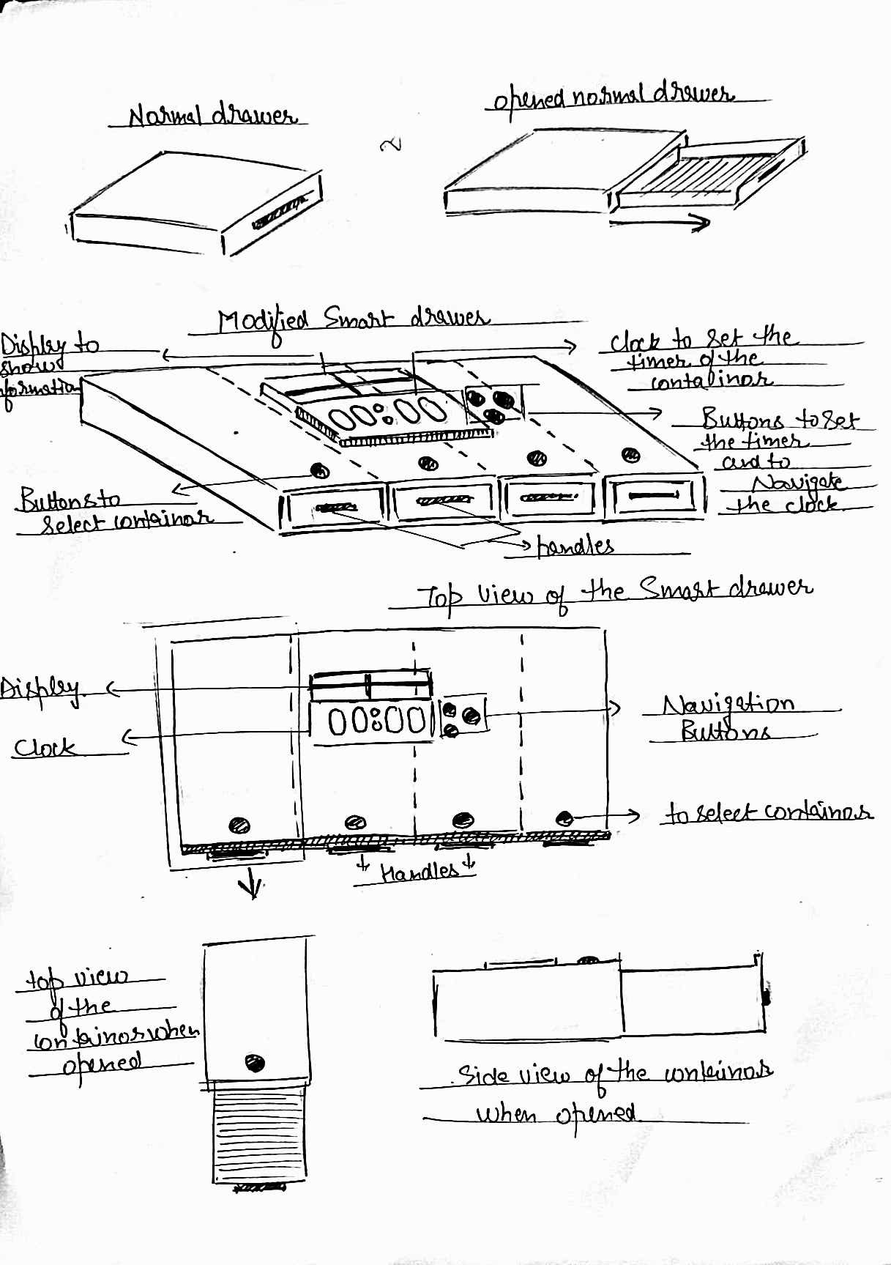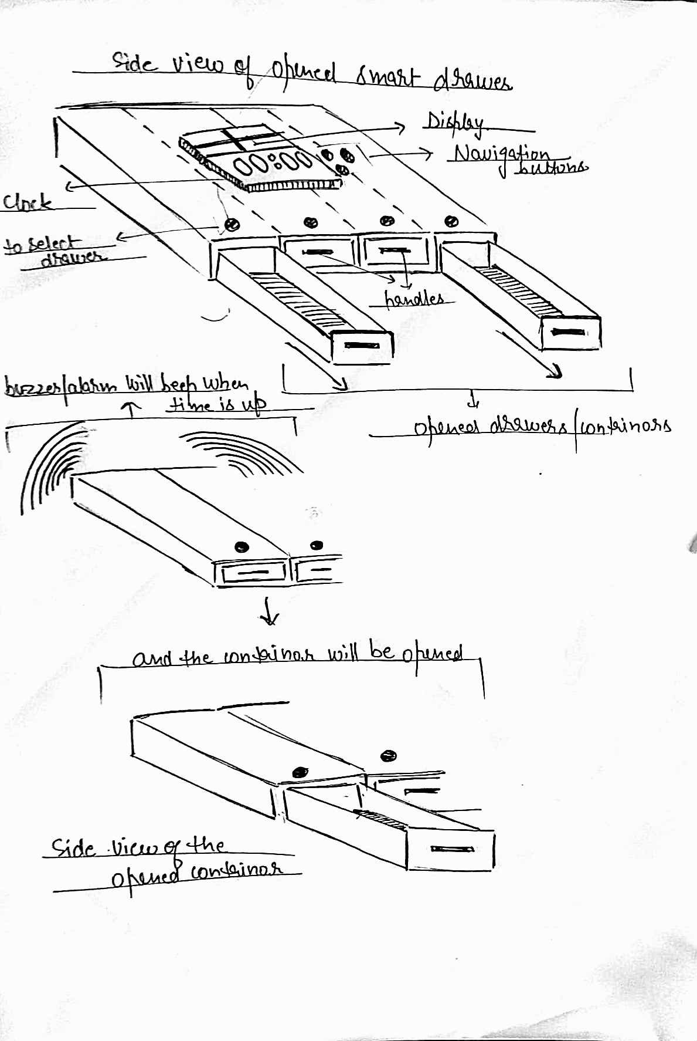

12 (a) Technical features and Elements of the invention.

* Every drawer has button on it to set the alarm.
* Alarm buzzer will start when it is time to take medicine.
* Display on the top is installed.
* Two sensors are installed in it i.e. weighting sensor and alarm sensor.
* In this automatic drawers are fitted.

13. Mention the Differences in invention and prior art (Patent and NPL in the search report).

Following are difference from the prior art:

|  |  |  |  |
| --- | --- | --- | --- |
| S.no | Name of the prior art | Key features of prior art | Key features of our invention |
| 1. | Drawer | The drawer is only used for storage purpose and further it has no use. | Our invention will not only provide storage but it will make it automatic as drawer can come out of its own when it is time to take medicine. |
| 2. | Alarm clock | People use alarm clock when they need reminder. | In our invention alarm clock is fitted on the top of the smart medicine drawer. We can set an alarm in the drawer itself. we don’t need alarm clock separately. |

14. Problem your invention is solving

* Patient can take medicine on its own.
* No person is required to remind patient that its time take medicine.
* Person can never miss his or her medicine.
* In hospitals nurses don’t have to come again and again to give medicines as our smart medicine drawer will remind patient that he has to take medicine on this time.
* Nurses will know how much medicine is left in the drawer with the help of display on the top.

15. Provide any additional material (such as photographs, reports, publications, and references to texts or other information material) which may be helpful to an understanding of the invention identify and indicate the specific relevance of each.

16. Drawings (If Any)

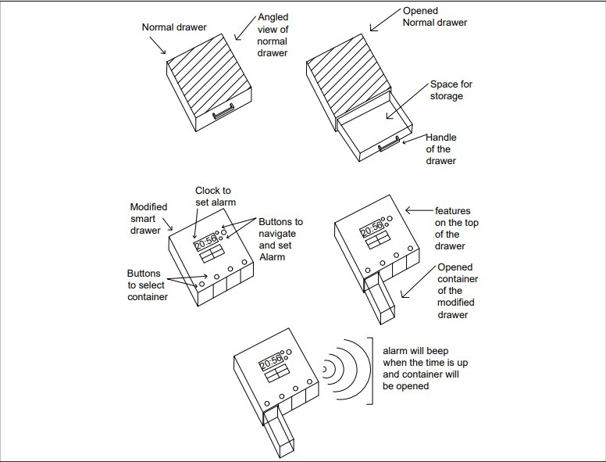

17. Briefly state when and how you first conceived this idea?

Once, Me and my friends Deekshant, Vandana and Vikas went to hospital to look our friend as he was admitted in the hospital. There we saw that nurses have to do lot of work and it is very difficult for them to look after each and every person at the same time. Some time they have to go the different rooms to take tests of the patient and the patient who left in the ward have only one or two nurse to look after them and for those nurses it was very tough to give medicine to all patients on time. So at that time we got this idea of smart medicine drawer which will ease the work of nurse staff and make patients capable of taking there medicines on its own.

18. Have you sold, offered for sale, publicly used or published anything related to this invention? If yes, please briefly explain the dates and circumstances. List those individuals to whom you have revealed your invention. Were non discloser documents signed prior to discloser in each case? Please state any deadlines of which you may be aware for filing an application on this invention. **NA**

19. Have you constructed a prototype? Yes/No **NO**

Has it been tested/used? Yes/No **NO**

Do you have records or log books documenting the conception/development of your invention? Yes/No **NO**